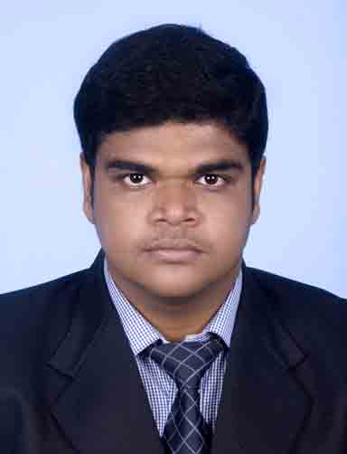

Souvik Chakraborty

**Mobile:** +917003817209

**Residence:** 033 2524-1327

**e-mail:** souvik.mba.1989@gmail.com

|  |
| --- |
| CAREER OBJECTIVE |

To work with a reputed & Growth-Oriented Organization in challenging environment, where I can utilize & develop my potential to help the Organization & myself and makes my work attractive enabling continuous learning.

|  |
| --- |
| summary |

* Diploma in Electronics & Tele-Communication Engineering from Kingston Educational Institute under West Bengal State Council of Technical Education.
* Completed B.Tech. in Electronics & Communication Engineering from West Bengal University of Technology.
* Completed Master In Business Administration from Heritage Institute of Technology under West Bengal university of technology.
* Working in Taxsoft Marketing Pvt Ltd as a Marketing Executive.
* Worked in ICICI Securities Ltd as a Sr. Relationship Manager.
* Good analytical and communication skills.
* Active participation in various technical projects from thecollege**.**

|  |
| --- |
| **ACADEMIC DETAILS :** |

|  |  |  |  |  |
| --- | --- | --- | --- | --- |
| **Examination Passed** | **Institute** | **University/Board** | **Marks obtained %/YGPA/DGPA** | **Year of Passing** |
| MBA | H.I.T | W.B.U.T | 7.25 | 2013 |
| BTECH | D.I.A.T.M | W.B.U.T | 6.8 | 2011 |
| DIPLOMA  ENGINEERING | K.P.C | W.B.S.C.T.E | 73.2% | 2008 |
| Madhyamik Examination | N.B.H.S | W.B.B.S.E | 66.25% | 2005 |

|  |
| --- |
| AREA OF INTEREST |

* SALES / MARKETING
* ELECTRONICS AND COMMUNICATION ENGINEERING.

|  |
| --- |
| **EXTRA CURRICULAR ACTIVITIES / HOBBIES** |

#### Riding Bike.

#### Playing Cricket.

|  |
| --- |
| **SPECIAL ACHIEVEMENTS** |

1. Done a summer internship of 8 weeks from **PEPSICO INDIA HOLDINGS PRIVATE LIMITED** on a project named “Retailer Perceptions Of Cheetos Extruded Products And A Study Of Competitors In That Sphere.”

|  |
| --- |
| **JOB EXPERIENCE** |

* Worked in **ICICI SECURITIES LTD**. As a Sr. Relationship Manager for more than 2 months.
* Working in **TAXSOFT MARKETING PVT LTD.** as a Marketing Executive from March 2015.

|  |
| --- |
| **Personal DETAILS** |

|  |  |
| --- | --- |
| **Date of Birth**: | 17th August, 1989 |
|  |  |
| **Father’s name**: | Mr. Sanjay Chakraborty |
| **Mother’s name**: | Mrs. Gita Chakrabarty |
| **Gender:** | Male |
| **Marital Status:** | Single |
| **Nationality:** | Indian |
| **Language Proficiency:** | English, Bengali & Hindi |
| **Location Preference**: | Nothing Special |
| **PAN NO :**  **Permanent Residential Address:** | AMMPC1843M  Baniniketan School Road, P.O- Nabapally P.S- Barasat Kolkata-700126. |

**DECLARATION**

I hereby declare that the information furnished above is true to the best of my knowledge.

(Souvik Chakraborty)